**Project Planning Phase**

**Project Planning (Product Backlog, Sprint Planning, Stories, Story points)**

|  |  |
| --- | --- |
| Date | 6 Nov 2023 |
| Team ID | PNT2022TMIDxxxxxx |
| Project Name | Fake/Real Logo detection using deep learning |
| Maximum Marks | 8 Marks |

**Product Backlog, Sprint Schedule, and Estimation (4 Marks)**

|  |  |  |  |  |  |  |
| --- | --- | --- | --- | --- | --- | --- |
| Sprint | Functional Requirement (Epic) | User Story Number | User Story/Task | Story Points | Priority | Team Members |
| Sprint 1 | Protect brand identity and prevent fraud | US-1 | Automatically detect fake logos | 5 | High | 1,2 |
| Sprint 2 | Automate logo authentication | US-2 | Get notified of unauthorized logo usage | 3 | Medium | 2,3 |
| Sprint 3 | Automate logo authentication | US-3 | Verify the authenticity of logos before making a purchase | 2 | Low | 3,4 |
| Sprint 4 | Protect brand identity and prevent fraud | US-4 | Train the system to detect specific brand logos | 5 | High | 1,2 |
| Sprint 5 | Automate logo authentication | US-5 | Customize the system to alert for specific types of unauthorized logo usage | 3 | Medium | 2,3 |
| Sprint 6 | Ensure the authenticity of products or services | US-6 | Easily access the system to verify the authenticity of logos | 2 | Low | 3,4 |

**Project Tracker, Velocity & Burndown Chart: (4 Marks)**

|  |  |  |  |  |  |  |
| --- | --- | --- | --- | --- | --- | --- |
| **Sprint** | **Total Story Points** | **Duration** | **Sprint Start Date** | **Sprint End Date (Planned)** | **Story Points**  **Completed (as on**  **Planned End Date)** | **Sprint Release Date (Actual)** |
| Sprint-1 | 20 | 4 Days | 9 Oct 2023 | 13 Oct 2023 | 20 | N/A |
| Sprint-2 | 20 | 4 Days | 14 Oct 2023 | 18 Oct 2023 | 18 | N/A |
| Sprint-3 | 20 | 4 Days | 19 Oct 2023 | 23 Oct 2023 | 19 | N/A |
| Sprint-4 | 20 | 4 Days | 24 Oct 2023 | 28 Oct 2023 | 11 | N/A |
| Sprint-5 | 20 | 4 Days | 29 Oct 2023 | 1 Nov 2023 | 19 | N/A |
| Sprint-6 | 20 | 4 Days | 2 Nov 2023 | 6 Nov 2023 | 20 | N/A |

**Velocity:**

Imagine we have a 10-day sprint duration, and the velocity of the team is 20 (points per sprint). Let’s calculate the team’s average velocity (AV) per iteration unit (story points per day)

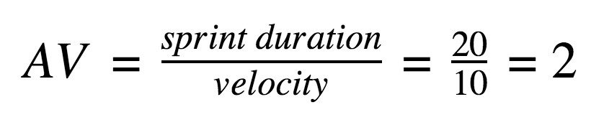

**Burndown Chart:**

A burn down chart is a graphical representation of work left to do versus time. It is often used in agile [software development](https://www.visual-paradigm.com/scrum/what-is-agile-software-development/) methodologies such as [Scrum.](https://www.visual-paradigm.com/scrum/scrum-in-3-minutes/) However, burn down charts can be applied to any project containing measurable progress over time.